Patient Name: __________________________________   DOB: ___________ Date:_________

**Background/History**

Current Medications: ______________________________________________________

Ongoing Medical Conditions/Diagnoses: _______________________________________

Prior and/or Scheduled Surgeries: ____________________________________________

Cognitive status (Check all that apply): __alert; __responsive; __cooperative; __oriented;  __confused; __lethargic; __impulsive; __uncooperative; __combative; __unresponsive

Current diet (check all that apply):

Solids: __regular; __mechanical soft; __chopped/minced; __pureed; __other

Liquids: __thin; __nectar thick; __honey thick; __pudding thick; __other

Adaptive equipment: __________________________________

NPO: __NG; __G; __NJ; __GJ

Feeding method: __Independent; __Needs assistance; __Dependent

Respiratory state (check one): __WNL      __Mildly impaired

__Moderately impaired  __Severely impaired

Comments: __________________________________________________

Eating environment at home: ________________________________________________

Speech intelligibility in conversation:

___Good

___Fair

___Poor

Comments:

Symptoms reported by patient (Check all that apply):

__Drooling

__Coughing

__Choking

__Difficulty Swallowing: __Solids; __Liquids; __Pills

__Pain when Swallowing

__Food gets stuck

__Weight Loss

__Hx of aspiration and/or pneumonia (Circle which apply)

__Fatigue during mealtime

__Other: _______________________________

Comments (frequency, duration, etc.): ________________________________________________________________________________________________________________________________________________________________________________________________________________________________________________

**Oral Mechanism**

|  |  |
| --- | --- |
| Dentition | __Natural teeth; __Partially/Fully Edentulous; __Dentures (check all that apply)                              __top                              __bottom  Dental hygiene: __Adequate; __Poor  Comments:_________________________ |
| Occlusion | ___WNL            ___Class II Malocclusion (overbite)                            ___Class III Malocclusion (underbite)                            ___Open bite                            ___Crossed bite |
| Palate | ___WNL            __Bluish; __Bifid uvula; ___Fistula                    Arch: __High; __Narrow; __Flat; __Wide |
| Tonsils | ___Present        ___Absent ___Large |
| Uvula | ___WNL/Midline  ___Pointing Left  ___Pointing Right |
| Tongue | ___WNL           Size: __Large __Small                           Atrophy: __Left __Right                           __Abnormal Fasciculations                           __Ankyloglossia                           __Xerostomia                           __Excessive saliva |

|  |  |  |  |
| --- | --- | --- | --- |
| **Nerve** | **Task** |  |  |
| **Trigeminal (V)** | Clench teeth, relax, clench again as clinician palpates masseter/temporalis | WFL | __Weakness:  __R __L |
| Open mouth wide | WFL | __Deviation:  __R __L |
| Keep mouth open with resistance | WFL | __Weakness |
| Move jaw side-to-side | WFL | __Reduced ROM:  __R __L  __Weakness:  __R __L |
| **Facial (VII)** | Alternate pucker and smile (oo--ee) | WFL | Weakness: __R __L |
| Puff out cheeks | WFL | Weakness: __R __L |
| Smile | WFL | Reduced ROM: __R __L |
| Pucker lips | WFL | Weakness/Decreased tone: __R __L |
| Close eyes tightly | WFL | Weakness: __R __L |
| **Vagus (X)** | Laryngeal elevation (assess during food trials) | WFL | __Reduced excursion |
| Cough | WFL | __Weak |
| Voice (informal observation) | WFL | __Breathy __Strained __Reduced Loudness __Aphonia __Monotone __Diplophonia __Abnormal Pitch __Other:_________ |
| Palatal elevation (ah--ah--ah) | WFL | __Weakness: __R __L |
| **Hypoglossal (XII)** | Tongue protrusion | WFL | __Decreased ROM  Deviation: __R __L |
| Tongue protrusion with resistance | WFL | __Weakness |
| Tongue lateralization | WFL | __Decreased ROM: __R __L |
| Tongue-tip elevation | WFL | __Decreased ROM: __R __L |
| Tongue push on cheek with resistance | WFL | __Weakness: __R __L |
| Sensory Concerns: | | | |

|  |  |
| --- | --- |
| **Motor Speech** | |
| AMRs   * P * T * K | ___WNL ___Problem  Comments: |
| SMRs   * “puh-tuh-kuh” * “buttercup” | ___WNL ___Problem  Comments: |
| Speech intelligibility | Known contexts:  ___Good ___Fair ___Poor  Unknown contexts:  ___Good ___Fair ___Poor  Comments: |

**Food Presentations:**

Position during assessment: __upright; __slightly reclined; __fully reclined

Comments: ___________________________________________

|  |  |  |  |  |  |
| --- | --- | --- | --- | --- | --- |
|  | **Presentation (e.g., spoon, straw, cup, self-fed, fed by examiner)** | **# of Trials** | **Amount** | **No s/s of aspiration** | **Response/Comments/**  **Strategies Trialed** |
| Ice Chips |  |  |  |  |  |
| Thin |  |  |  |  |  |
| Nectar-thick |  |  |  |  |  |
| Pudding-thick |  |  |  |  |  |
| Puree:_________ |  |  |  |  |  |
| Mixed consistency:  _______________ |  |  |  |  |  |
| Solid: ____________ |  |  |  |  |  |

**Findings:**

**Swallowing**

__ Swallowing WNL

Swallowing diagnosis:

__dysphagia unspecified

__oral phase dysphagia

__oropharyngeal phase dysphagia

__pharyngeal phase dysphagia

__suspected esophageal dysphagia

Severity:

__mild __mild/moderate

__moderate __moderate-severe

__severe

Characterized by: ___________________________________________________________

**Motor Speech**

___Motor Speech WNL

Motor speech diagnosis:

___(mild, mild-moderate, moderate, moderate-severe, severe) apraxia of speech

___(mild, mild-moderate, moderate, moderate-severe, severe) dysarthria

Characterized by: ___________________________________________________________

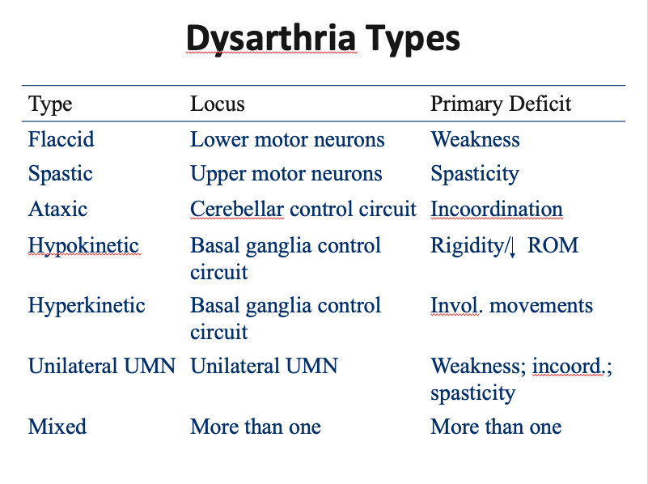Dysarthria type:

__ataxic

__hypokinetic

__hyperkinetic

__spastic

__flaccid

__mixed

__unilateral upper motor neuron

**Recommendations:**

Instrumental assessment: __yes; __no

      __ MBS __FEES

Swallowing tx: __yes; __no

Frequency:______ Duration:_________

Diet Recommendations:

Solids: __regular; __soft(advanced); __mechanical soft(minced and moist); __pureed(extremely thick);  __liquidized __other

Liquids: __thin; __nectar thick(slightly/mildly thick);__honey-thick(moderately thick)         __pudding thick(extremely thick); __other

NPO: ________________________________________________________

Modified diet with supplemental tube feeds: __________________________

Alternative nutrition method with pleasure feeds: ______________________

**Safety precautions (check all that apply):**

__Supervision needed during mealtime

__1:1 supervision

__To be fed only by trained staff/family member

__To be fed only by SLP

__Feed only when alert

__Reduce distractions

__Verbal cues to use recommended strategies

__Small sips and bites when eating

__Slow rate; swallow between bites

__No straw

__Sips by straw only

__Multiple swallows

__Alternate liquids and solids

__Sensory enhancement (flavor, texture, temperature)

__Other

Recommended referrals (if applicable): ________________________________________________________________________________

Comments: ________________________________________________________________________________________________________________________________________________________________________________________________________________________________________________

Patient/Caregiver education: ________________________________________________________________________________________________________________________________________________________________________________________________________________________________________________

Prognosis: _______________________________________________________________________

**Long term goal(s):**

**Short term goals:**

Signature:____________________________________ Date:___________________